Subject: English Language Arts
Unit of Study: Fables and Folklore
This week, The Empty Pot and tales that emphasize truth is an important quality
Time Frame for Instruction: 1 week |  |  |  |  | Dates: April 6-10
Course Requirements:
AAD.6.L.VAU.1 Use context cues including graphics or photos to determine the meaning of a word.
AAD.6.R.CS.1 Identify the structure of a drama, dialogue, or informative text features (i.e., photos with captions, data, headings, etc.).
AAD.6.R.KID.1 Quote or cite examples from the text when answering explicit questions.
AAD.6.R.KID.2 Explain or cite information from the text to support a fact, inference, or conclusion.
AAD.6.R.KID.3 Determine the central theme/main idea of a text read or heard.
AAD.6.R.KID.5 Describe the character(s), plot, or idea(s) of a story read or heard.
AAD.6.R.KID.6 Explain the relationship between two or more individuals, events, or ideas in a text read or heard.
AAD.6.W.PDW.2 Use technology to produce and publish writing*.
AAD.6.W.RW.10 Routinely practice writing* skills for a variety of tasks, purposes, and audiences.
Targeted Vocabulary:  - Empty/full  - Pot/planter  - Emperor  - Fable  - Moral  - Character  - Plot |  |  | Strategies for Teaching Vocabulary:  Develop vocabulary cards for personal dictionary  Develop synonym paint chip cards |  |  |  |  | Needed Materials:  Paper, index cards etc.  Symbols  Paint chip or paint chip graphic
Connections and Key Concepts:
Self:  I make my own choices. | Home:  It is important that I tell the truth and learn from my choices. |  |  | School/Routine Setting:  We have rules to guide our choices and consequences for each choice. |  | Community:  Stories from the past help us learn to make choices that are best for everyone. |  |  | World:  The stories of history teach us how to treat each other and honor our self.
Multisensory-Multimodal Strategies:
Video storybook, kinesthetically create their own vocabulary resources, share their story with a friend verbally, written, or video, teach others a few opposites or synonyms
Opportunities for Connections to Community, Independence, and Employment
- Use Zoom technology for class meeting like many business professionals |  | - Record and send a video—like news anchors, etc. |  |  |  |  | - Grow a seed—gardening, farming, landscaper, etc.
Materials and Resources Needed:  - https://www.storylineonline.net/  - Zoom/computers  - Basic crafts—paper, markers, crayon, tape or glue  - Communication symbols |  |  |  |  | Community Resources and Contacts:  Parents or caregivers

Day 1:
Prior to class, send the parents/caregiver and overview of the day including a file with the vocabulary symbols to print for the students to use, and the character sorting table. You may choose to send the symbols and materials for the whole unit in the US Mail or other delivery systems so the materials are ready for the first day.
Begin with an opening class meeting using Zoom or other technology to introduce the topic for the week’s ELA lessons.

Introduce vocabulary words:
- Fable—a story that teaches us an important lesson or how to make better choices.
- Moral—choosing the right behavior to treat yourself and others fairly and with kindness
- Character—2 meanings. We typically talk about the character as the person in the story or book but it is also used to describe how a person acts or their morals.
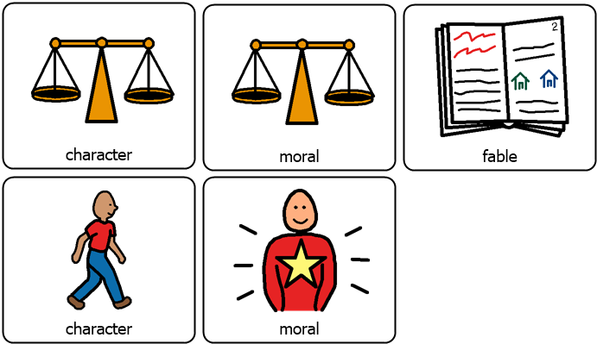
Practice the vocabulary having student choose between the symbols. You can provide a choice with student pointing or eye-gazing at the symbol on the screen or you can use software like Poll Everywhere if you have set up the poll ahead of time.
The students then follow your model to create a vocabulary card of their own using the symbols sent prior to the lesson. Glue the symbol to one side of an index card, scrap paper, or other paper “card”. One the back the student “writes” their own definition. These cards are for the student to use and refer to when communicating during the lesson or in their independent assignments. The written definition needs to be meaningful for them but now one else. Given this, for students for whom writing skills are still a struggle, they may make a drawing, symbol, or other written meaning for them to indicate the definition of the word.
Independent work connection: The students can complete the other three symbols on their own (two choices were given for moral depending on which has more meaning to the student). The student needs to be able to show you their work tomorrow for accountability of their independent work.
Introduce the lesson:
Today we will begin our study of fables. Fable was one of our new vocabulary words, does anyone remember what it means? That’s right, it is a story that teaches us about how to make better choices.
We are going to listen to a story together. I am so excited because the person reading you the story is Rami Malek. He is an actor and one of the animal voices in the new Doolittle movie. He is reading the book on Storylineonline.net. As we watch and listen today I am going to pause every once in a while to talk about our new vocabulary, ask you some questions, and give you a chance to make a few predictions.
Okay, let’s begin…
Start and stop the video at appropriate places to review the vocabulary, make predictions of what we think will happen next, and do comprehension checks to make sure the students are engaged.
Independent work connection: students can listen to the whole story with no pausing on their own using the link: https://www.storylineonline.net/books/the-empty-pot/
Lesson:
Central Theme—Moral of the Story
Review the vocabulary words “fable” and “moral”. Discuss the message of the story and what lesson the author was trying to teach.
- What important choice did Ping make in the story? Was that an easy choice or a hard one for him? Why?
- What choice did Ping’s friends make? Why do you think they made that choice?
- What was the moral of the story?
- Why is it important for people to tell the truth?
- Why would it be important to the Emperor that the person he selects tell the truth?
- Why are fables important to read?
- Discuss other stories that teach lessons.
- Tortoise and the Hare
- The Loin and the Mouse
- The Ants and the Grasshopper
- The Boy Who Cried Wolf
Independent work connection: Students can read or watch these fables or others they have access to in the home or online.
Story elements: Characters
Let’s create a list of all the characters in the story. (Emperor, Ping, Ping’s father, Ping’s friend, children)
If needed, create symbol or initials with a person picture for those students who are currently not communicating verbally or to provide access using the student’s communication system. For example, using an AAC device the student could indicate “man” and “e” for the emperor.
Discuss the difference between a main character and other characters. The students will need to sort the characters into “main” and “supporting” using the chart below.
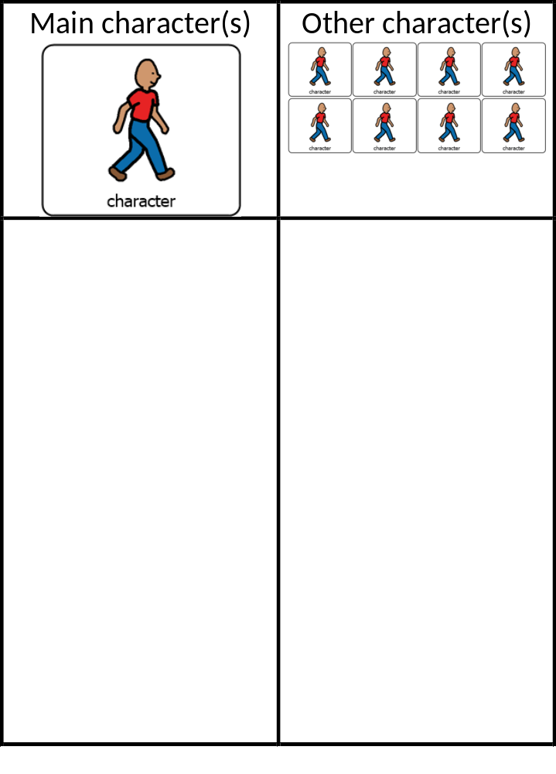
Close the daily lesson:
Ask students to complete their vocabulary and if they are interested, review the story or other fables. Preview tomorrow’s lesson to discuss the details of the story and continue to work on the new vocabulary, characters, and other fun information.

Day 2:
Prior to class, send the parents/caregiver notice that the students will be using Google Earth and a link should the family choose to use the same site later. Also, ensure students have access to watercolors, markers, crayons or other drawing medium as well as paper. You may have already sent a “school tools” kit home, but if not, send the materials as needed in advance of the lesson.
Begin with an opening class meeting using Zoom or other technology to introduce the topic for the week’s ELA lessons.

Introduce vocabulary words:
- Emperor—Ruler of a country. The person who makes the rules and decisions for the county they represent.
- Character—2 meanings. We typically talk about the character as the person in the story or book but it is also used to describe how a person acts or their morals.
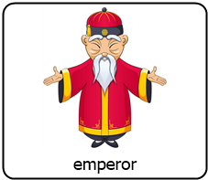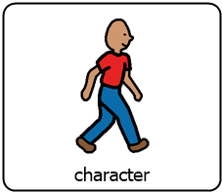
Practice the vocabulary having student choose between the symbols. You can provide a choice with student pointing or eye-gazing at the symbol on the screen or you can use software like Poll Everywhere if you have set up the poll ahead of time.
The students then follow your model to create a vocabulary card of their own using the symbols sent prior to the lesson. Glue the symbol to one side of an index card, scrap paper, or other paper “card”. One the back the student “writes” their own definition. These cards are for the student to use and refer to when communicating during the lesson or in their independent assignments. The written definition needs to be meaningful for them but now one else. Given this, for students for whom writing skills are still a struggle, they may make a drawing, symbol, or other written meaning for them to indicate the definition of the word.
Independent work connection: The students can complete the other three symbols on their own (two choices were given for moral depending on which has more meaning to the student). The student needs to be able to show you their work tomorrow for accountability of their independent work.
Introduce the lesson:
Today we will begin talk about historical culture, fiction, or characters. Just like when we talk about history in social studies, we are talking about things that have already happened, sometimes even longer ago than when our grandparents were babies. Yes, that was a long time ago. History is important because it helps us understand why things are the way they are today.
Lesson:
Historical Characters and Stories (Fables) from the Past
There are rulers, or chiefs, in most countries. Sometimes they are referred to as an Emperor. But we have other names for rulers. Can you think of any other rulers we have talked about or that you learned about in other classes? Maybe a ruler of a state, country, city, or town? (President, king, queen, chief, governor, mayor, etc.)
Discuss what rulers do for the community and the expectations of their job. Then talk about what the average day might look like for a ruler.
Now let’s talk about the character of a ruler. Let’s look at the Emperor in The Empty Pot. What hints did the story give us about his character? (discuss)
Talked about what a ruler has to do and it is not a simple or easy job. Let’s now talk about the kind of ruler they would be if their character was: (example, didn’t listen, didn’t like to go to work, was afraid of making choices)? Describe different character traits, positive and less positive, and how that person may rule.
Historical fiction also helps us know what it was like to live long ago. In the story, we learn about what was important by descriptions of Ping’s day. What do you think it was like then? (discuss)
I wonder what China is like now? Let’s find out! How about if we take an imaginary field trip to China using Google Earth.
Use Google Earth to “travel” to China. Visit the different areas fo the country, both the rural and the cities and have the students discuss what they notice. What is similar to their community? What is different? Does this look like a place you would like to visit for real? Why or why not? The goal here is not to have them like China, but to practice communicating, listening to others, sustaining focus on a topic, etc. You can even give students presenter rights on most video conferencing tools and then they can be the “tour guide.”
Independent work connection: Students can visit other countries or states using Google Earth.
Story elements: Setting
Setting is where the story takes place. We are going to look at our story pictures. There are a few different settings. I want you to look for them. Then we are going to have a chance for you to paint or draw the settings you saw as we talk about them.
The students will engage in drawing using a medium most appropriate for them and of interest. While they are working, talk about the setting in the book including, China, Ping’s home, the garden, at the park or school with his friends, at the palace, etc. The goal is to help them understand the variety of settings and how we can identify a setting form the story clues.
Close the daily lesson:
Ask students to complete their vocabulary and if they are interested, review the story or other fables. Preview tomorrow’s lesson to discuss rhyming and the plot of a story.

Day 3
Similar structure.
Vocabulary of focus: pot/planter and plot.
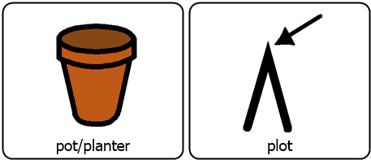
Lesson: rhyming
Story elements: Plot

Day 4

Vocabulary focus: empty and full
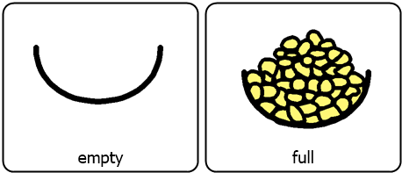
Lesson: opposites
Story Elements: Plot
Day 5
Summary activity:
- Act out the story.-
- Retell it using an American point of view with a President and the student earning the vote.
- Write a new ending.
Hint at the next week’s learning.

